HW#3
Farhad Ramezanghorbani

import math
import random
#result=open("realplot.txt","w")
def x(y,lan):
return float(-math.log1p(-y)/lan)

lan=float(raw_input("Enter the value of Landa:\n"))
n=float(raw_input("Number of steps:\n"))
s1=0.0
s2=0.0
s3=0.0
s4=0.0
s5=0.0
s6=0.0
s7=0.0
s8=0.0
s9=0.0
s10=0.0
count=0
while (count <= n):
y=random.random()
r=x(y,lan)

if r<1/lan:
s1+=1
elif r<2/lan:
s2+=1
elif r<3/lan:
s3+=1
elif r<4/lan:
s4+=1
elif r<5/lan:
s5+=1
elif r<6/lan:
s6+=1
elif r<7/lan:
s7+=1
elif r<8/lan:
s8+=1
elif r<9/lan:
s9+=1
else:
s10+=1
#p=float(lan*math.exp(-lan*count))
#output=str(p)+"\n"
#result.write(output)
#count+=1
print s1/n
print s2/n
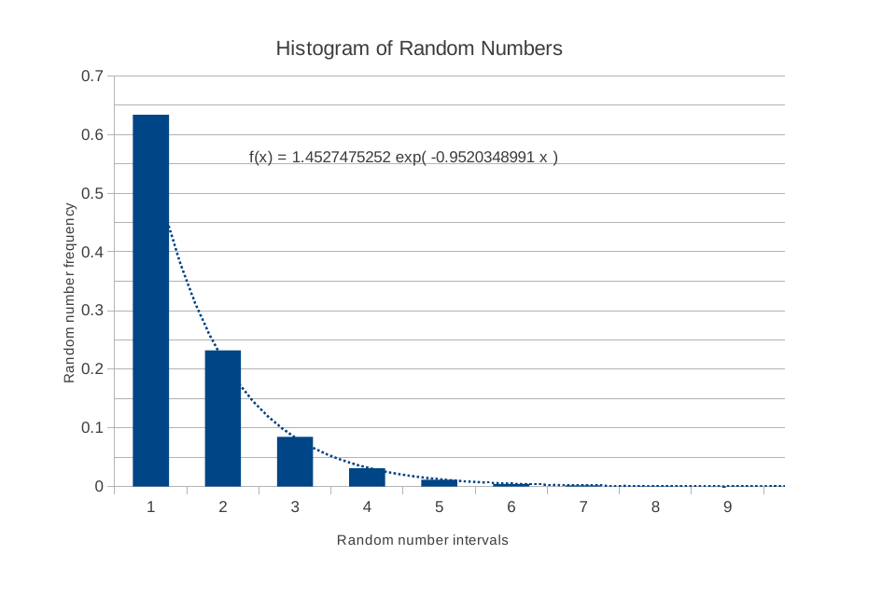
print s3/n
print s4/n
print s5/n
print s6/n
print s7/n
print s8/n
print s9/n
print s10/n

Results for:
landa=0.01
Trials=10**5

are:
0.63299
0.23038
0.08718
0.03091
0.01197
0.00414
0.0016
0.00051
0.00025
8e-05

The problem with my code will appear when I wanted to compare the fitted trend line of histogram (the blue dotted line) with exponential distribution (lan*exp(-lan*t)). the fitted trend line should start from landa which is 0.01 not 0.63. I could not make it until deadline but I will try to solve this problem.

The mean value (Expected value) of exponentially distributed random variables with rate parameter landa (exp(lan)) is 1/lan.

I categorized my random numbers with the groups of 1/lan multiplied by integers. 50 % of data should be in the first column. But there is more than 60%, this is a sign that shows random number generator is not as good as it seems.

